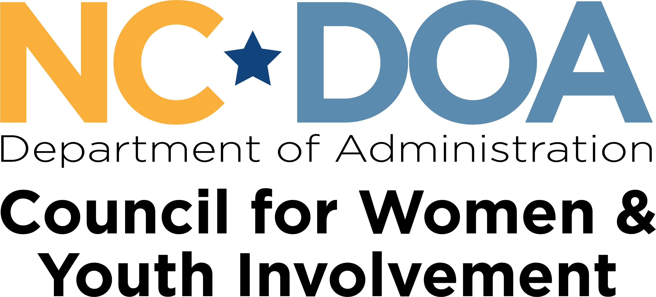

Memorandum of Understanding Between
Name of Domestic Violence Intervention Program
(insert provider name above)
Hereinafter referred to as DVIP
and
Victim Service Agency
(insert DV Agency name above)
Hereinafter referred to as VSA

WHEREAS, the DVIP has developed a program to provide assessment and psycho-educational services in click or tap here to enter text County for persons who have been determined to be in need of such services;

WHEREAS, the VSA is the domestic violence victim assistance provider in click or tap here to enter text County, and it provides assessment and other services to victims of domestic violence such as: a 24 hour domestic violence crisis line; shelter; confidential free individual and group counseling; assistance with the development of safety plans; and access to information regarding, and referrals to, other available resources (including referrals to Legal Aid of North Carolina for assistance with domestic violence protective orders and other legal options); and

WHEREAS, the parties here wish to collaborate and cooperate in the delivery of services in domestic violence cases, and to have in place a Memorandum of Understanding (“MOU”) regarding that collaboration and cooperation.

THEREFORE, the parties set forth their mutual agreement and understanding as follows:

Goals of Agreement:

1. To acknowledge the commitment of both the VSA and the DVIP to establish a cooperative working relationship that will facilitate the establishment and provision of effective services to victims and offenders in domestic violence cases.
2. To define basic roles and responsibilities of each agency and the mechanism for disseminating information and resolving problems.
3. To clarify the mechanisms and procedures for clients to be referred from one system to the other.

Substance of Agreement:

The DVIP will:
- Provide assessment and psycho-educational group and individual services.
- Assist the abuser to develop, maintain, and meet appropriate goals.
- Meet the minimum standards and requirements specified by the North Carolina Domestic Violence Commission and Council for Women and Youth Involvement.
- Ensure that DVIP staff and volunteer counselors, facilitators, and co-facilitators who provide services are trained in domestic violence issues.
- Maintain regular contact with the VSA regarding (a) safety issues of victims; (b) opportunities for domestic violence training for counselors, facilitators, co-facilitators, victims’ advocates, and others in the community who interact with or provide services; (c) improving and expanding services; (d) identifying, discussing, and resolving any issues or problems that may arise in connection with the DVIP, victim safety or confidentiality, this MOU, or the parties’ collaborative relationship; and (e) any other issues that may further the parties’ mutual goals of improving community attitudes and institutional responses toward domestic violence.
- Subject to the limitations set forth below, the DVIP shall make good faith attempts, which shall be documented, to make contact with the victim: (a) upon a participant’s enrollment in its program ; (b) when the participant has completed half of the sessions; and (c) when the participant completes or otherwise terminates participation in the program. These contacts shall be in writing, and the initial contact shall include information about the program and its limitations, victim confidentiality, the VSA, and other local resources for victims. The DVIP shall collaborate with the VSA in making these contacts and, if the victim is a client of the VSA, the DVIP shall provide the VSA with a copy of what is provided to the victim. The DVIP shall have no obligation to contact the victim if he/she cannot be located.
- However, notwithstanding the foregoing, the DVIP shall comply with any court ordered requirements or limitations regarding contact with the victim and it shall not contact the victim if: (a) there is a domestic violence protective order or other court order in place that prohibits direct contact by the DVIP with the victim; (b) the court or the victim specifies that contact with the victim shall be made only indirectly through the VSA, the victim’s attorney, or other representative of the victim; or (c) the victim declines contact.
- The DVIP may provide direct services to both abusers and victims. However, the same DVIP staff person or volunteer shall not provide services to both a victim and her/his abuser. The DVIP shall not schedule victims’ groups and domestic violence intervention groups at the same or overlapping time at the same facility. Similarly, the DVIP shall not schedule an individual session with a particular victim and her/his abuser at the same or overlapping time at the same facility. The DVIP staff member or volunteer working with the victim shall not provide any information from or about the victim to the staff member or volunteer working with the abuser without the express written consent of the victim.
- The DVIP shall keep the VSA informed of the programs and services that the DVIP may provide to victims. The DVIP may not directly solicit a VSA client to take part in any DVIP programs or services.
- The DVIP shall keep all information about or from the victim confidential and specifically shall not provide such information to the abuser program participant; the DVIP will disclose information about or from the victim only pursuant to a court order or with the express written consent of the victim.

The VSA will:
- Collaborate with and assist the DVIP in connection with the DVIP’s obligation to make contact. If the victim so requests, or if a court order so requires, the VSA will serve as the conduit for purposes of the delivery of information from the DVIP to the victim. The VSA will make a good faith effort to offer its services to and maintain contact with victims whose abusers are participating in the DVIP, including for purpose of monitoring safety issues, and delivering information from the DVIP to the victim. However, the VSA shall have no such obligation to maintain contact or provide services if the victim declines such contact or assistance from the VSA or if the victim cannot be located.
- Maintain regular contact with the DVIP regarding: (a) safety issues of victims; (b) opportunities for domestic violence training for counselors, facilitators, co-facilitators, victims’ advocates, and others in the community who interact with or provide services to victims or abusers; (c) improving and expanding services available to victims and abusers; (d) identifying, discussing, and resolving any issues or problems that may arise in connection with the DVIP, services being provided to abusers or victims, victim safety or confidentiality, this MOU, or the parties’ collaborative relationship; and (e) any other issues that may further the parties’ mutual goals of improving community attitudes and institutional responses toward domestic violence.
- Provide ongoing consultation to the DVIP’s staff, and provide periodic training opportunities to the DVIP’s counselors, facilitators, and co-facilitators about domestic violence issues.

AMENDMENTS: This Memorandum of Understanding may be amended only in writing signed by both parties. The parties agree to make a good faith effort to make amendments that may be necessary to achieve the goals and commitments set forth herein.

TERMINATION: The MOU may be terminated at any time upon mutual consent of both agencies. It may also be unilaterally terminated for good cause by either party if the other party fails to comply with the terms of the MOU, applicable standards of the North Carolina Council for Women and Youth Involvement, or the requirements of the North Carolina Administrative Code for abuser treatment programs. However, prior to any such unilateral termination for good cause, the party wishing to terminate must give the other party written notice of the alleged non-compliance and a 30-day opportunity to cure. Finally, the MOU may be terminated immediately and without notice and opportunity to cure for egregious non-compliance or misconduct such as a breach of victim confidentiality or fraud.

TERM: This agreement becomes effective on click or tap here to enter date and shall remain in effect for one year unless terminated as provided above.

__________________________ __________________________
Signature of the VSA Director Signature of DVIP Director

